SMART WATER MANAGEMENT

## COMPONENTS REQUIRED :

1. Sensors .
2. Electrode.
3. Resistor(10K).
4. 12V DC Power input.

## CIRCUIT DIAGRAM:

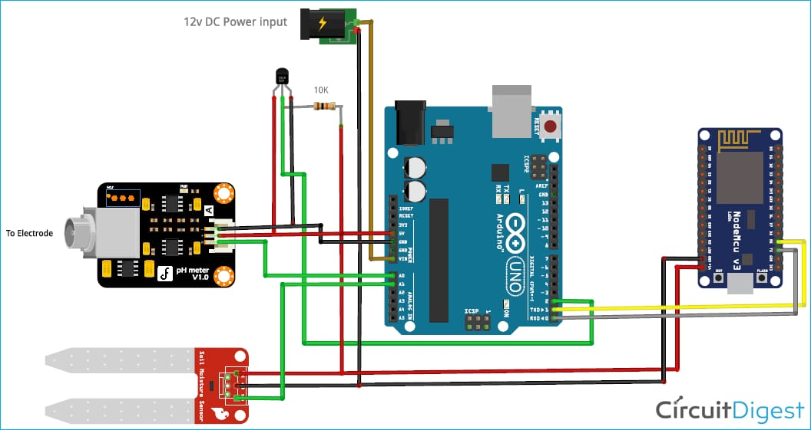

## CODING:

class WaterManagement:

def _init_(self, initial_water_level):

self.water_level = initial_water_level

def check_water_level(self):

return self.water_level

def add_water(self, amount):

if amount > 0:

self.water_level += amount

return f"Added {amount} liters of water. Current water level: {self.water_level} liters"

else:

return "Invalid input. Please provide a positive amount of water."

def use_water(self, amount):

if amount > 0:

if amount <= self.water_level:

self.water_level -= amount

return f"Used {amount} liters of water. Current water level: {self.water_level} liters"

else:

return "Not enough water available."

else:

return "Invalid input. Please provide a positive amount of water to use."

# Example usage:

if _name_ == "_main_":

water_manager = WaterManagement(1000) # Initialize with 1000 liters of water

print(water_manager.check_water_level()) # Check current water level

print(water_manager.add_water(200)) # Add 200 liters of water

print(water_manager.use_water(150)) # Use 150 liters of water

print(water_manager.use_water(1000)) # Try to use more water than available

print(water_manager.add_water(-50)) # Try to add a negative amount of water